**Gabon country profile**

Published

15 January 2019

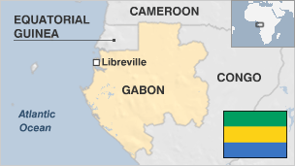

**Gabon, located on the west coast of Africa, has one of the region's more stable countries.**

Since independence from France in 1960, Gabon has had just three presidents. The late President Omar Bongo ruled for more than four decades until his death in 2009.

During Omar Bongo's rule, Gabon maintained a close relationship with France under a system known as "Francafrique", receiving both political and military support in exchange for business favours.

But relations have cooled since his son Ali won a contested election in 2009 and the French authorities launched a long-running corruption investigation into the family's assets.

Gabon is a major oil producer but a third of its population live in poverty, according to the World Bank.

* Read more [country profiles](http://news.bbc.co.uk/1/hi/country_profiles/) - Profiles by [BBC Monitoring](http://bbc.co.uk/monitoring)

**President: Ali Ben Bongo Ondimba**

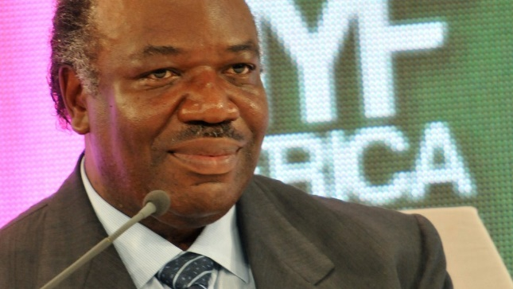image copyrightGetty Images

Ali Bongo was sworn in for a second seven-year term in September 2016, after Gabon's constitutional court upheld his narrow victory in a bitterly disputed election.

Main rival Jean Ping described the court's decision as a "miscarriage of justice" amid opposition claims of vote fraud.

Mr Bongo took over from his late father Omar, who ruled Gabon for 41 years until his death in 2009.

He pledged to address some of the issues that have fuelled anger among the country's 1.8 million people, like youth unemployment and over-reliance on falling oil revenues

But his presidency has been overshadowed by a long-running French investigation into allegations of embezzlement involving the Bongo family's assets.

He narrowly won re-election in 2016 in a poll marred by violence and accusations of fraud, and reportedly suffered a stroke in October 2018 that led to concerns about his ability to carry out his duties.

Gabon's main broadcast media are government-controlled.

Reporters Without Borders says self-censorship is commonplace.

# Gabon profile - timeline

Published

15 January 2019

## A chronology of key events:

**1470** - Portuguese arrive in what is now Gabon.

**1839** - Local Mpongwe ruler signs away sovereignty to the French.

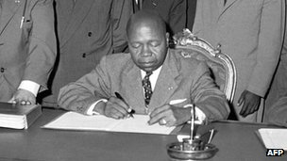image copyrightAFP

image captionLeon M'ba was Gabon's first post-independence leader

**1910** - Gabon becomes part of French Equatorial Africa.

**1958** - Gabon votes to become autonomous republic in the French Community.

**1960** - Gabon becomes independent.

**1961** - Leon Mba elected president.

**1964** - French forces restore President Mba after crushing a military coup.

**1967** - Albert-Bernard Bongo becomes president after Mr Mba dies.

**1973** - President Bongo converts to Islam and assumes the name Omar.

## Multi-party elections

**1990** - Opposition parties legalised, but accuse the government of fraud in parliamentary elections held in September and October.

**1991** - Parliament adopts a new constitution that formalises the multi-party system.

**1993** - Omar Bongo narrowly wins presidential election, the first held under the new multi-party constitution; opposition accuses government of electoral fraud.

## Constitution amended

**2003** July - Constitution changed to allow President Bongo to run for president as many times as he wishes.

**2004** February - French oil firm Total signs deal to export Gabonese oil to China.

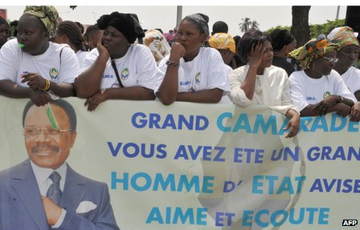image copyrightAFP

image captionOmar Bongo - president for 41 years - was succeeded by his son after his death in 2009

**2004** September - Agreement signed with Chinese company to exploit around one billion tonnes of iron ore.

**2006** February - Gabon and Equatorial Guinea agree to start talks over disputed islands in potentially oil-rich waters in the Gulf of Guinea.

**2009** February - French court freezes President Omar Bongo's bank accounts in the country after he was ordered to return a payment made to him to release a jailed French businessman, Rene Cardona.

## Presidential succession

**2009** June - President Omar Bongo dies while undergoing treatment at a clinic in Spain.

**2009** September - Ali Bongo, son of late president, named winner of August election. Critics say poll was fixed to ensure dynastic succession. Opposition supporters clash with security forces.

**2010** August - Bongo says France no longer its exclusive partner, as Gabon signs deals with India and Singapore for major infrastructure projects.

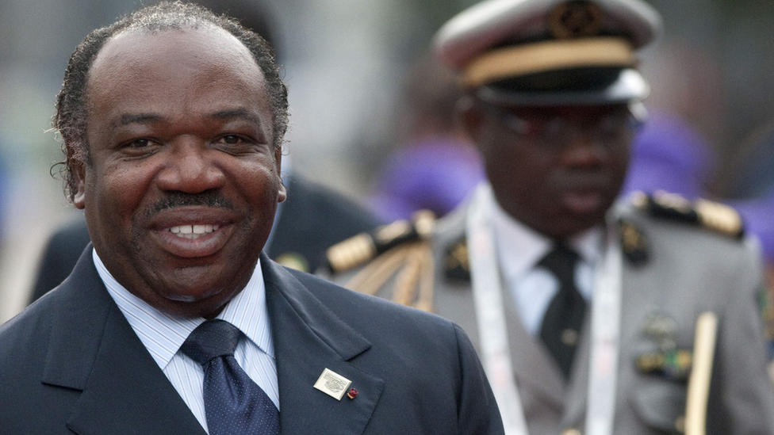image copyrightSEBASTIEN BOZON/AFP/Getty Images

image captionAli Bongo succeeded his father as president in 2009

**2012** January - Gabon and Equatorial Guinea co-host Africa Cup of Nations, the continent's biggest football tournament.

**2012** - Gabon drops French as its official language in favour of English.

**2015** February - Gabon lifts ban on main opposition party National Union (UN)

**2015** April - Main opposition leader Andre Mba Obame dies in Cameroon. Tens of thousands turn out to greet his coffin as it returns home.

**2016** September - President Ali Bongo is sworn in for a second seven-year term as the Constitutional Court upholds his narrow election victory over his main challenger Jean Ping.

**2017** February - A new report says Gabon has lost 80% of its elephant population over the past decade.

**2018** October - President Ali Bongo reportedly suffers a stroke and leaves the country for treatment.

**2019** January - A group of junior officers briefly attempt a coup against President Bongo, shortly before he returns from medical treatment abroad.